
Customer_retention_case study

Submitted by:
Gondesi Siva Ram Santosh Reddy

ACKNOWLEDGMENT

I wold like to add some refresences which helped me to solve this project
I have used some automated EDA for this projects called sweetviz, dtale and dataprep
https://pypi.org/project/sweetviz/
https://pypi.org/project/dtale/
https://pypi.org/project/dataprep/
For data analysis part i have used pandas, you can find the link below
https://pandas.pydata.org/
And for visualization i used matplotlib, seaborn,sweetviz for generating report and yellowbrick for vistualizing the metrics of the data
https://matplotlib.org/

https://seaborn.pydata.org

https://towardsdatascience.com/sweetviz-automated-eda-in-python-a97e4cabacde

https://www.yellowbrick.co

And at last for numerical calculation i used Numpy and Scipy
https://numpy.org

INTRODUCTION

- Business Problem Framing
Customer satisfaction has emerged as one of the most important factors that guarantee the success of online store; it has been posited as a key stimulant of purchase, repurchase intentions and customer loyalty. A comprehensive review of the literature, theories and models have been carried out to propose the models for customer activation and customer retention.

- Conceptual Background of the Domain Problem
Five major factors that contributed to the success of an e-commerce store have been identified as: service quality, system quality, information quality, trust and net benefit. The research furthermore investigated the factors that influence the online customers repeat purchase intention. The combination of both utilitarian value and hedonistic values are needed to affect the repeat purchase intention (loyalty) positively. The data is collected from the Indian online shoppers. Results indicate the e-retail success factors, which are very much critical for customer satisfaction

- Review of Literature
The combination of both utilitarian value and hedonistic values are needed to affect the repeat purchase intention positively. The data is collected from the Indian online shoppers. Results indicate the e-retail success factors, which are very much critical for customer satisfaction.

- Motivation for the Problem Undertaken
As a datascient we have tools and kowledge to handle the such data and draw insights from the data to easily visualize and represent the the way we can both vicually and statistically

Analytical Problem Framing

- Mathematical/ Analytical Modeling of the Problem
We used many statistical and mathematical function used in the project in python we have a library called pandas where we have some statistical functions like .describe() where we are checking some statistical informations like mean, median, standard deviation and percentils
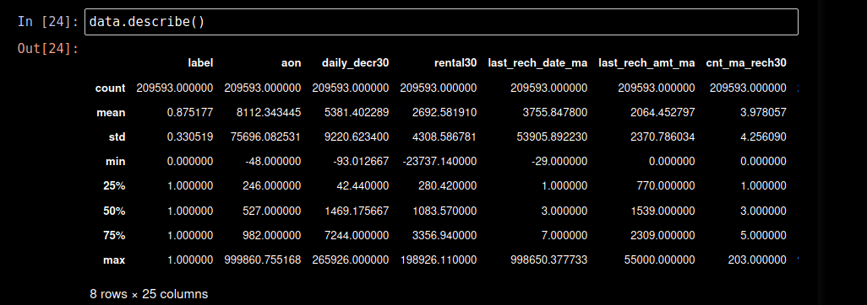
And there are so many other functions like z scores and IQR which are used in outliers detection and treatment and cheking the correlation and covarience of the data, by the analysis of the data set we found that there are many outliers in the data only some of them are handled and also data is skewed which are handled using power-transform method
- Data Sources and their formats
Data is provided by our client in the format of .CSV format we have to analyze the data using pandas library used in python
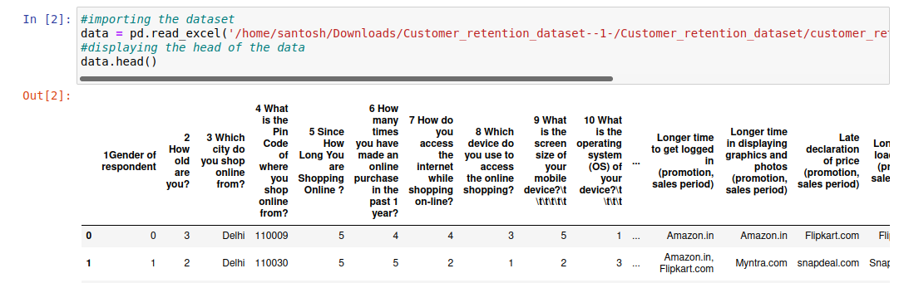
we can see by the above screenshot and we have total 71 columns and 269 observations in the data that is provided and it is a big dataset, there are no null values in the dataset but the dataset is pretty immbalanced.

- Data Preprocessing Done
There is no much datacleaning is done actually dataset mostly contain numerical columns and only one categorical columns which is dropped due to no use. And the preprocessing we have done for the dataset is we handled date column as it is in object type we have ot convert into datetime format by using a function in pandas .to_datetime functio And we have dropped some columns as they ar no use
- Data Inputs- Logic- Output Relationships
If we properly observe we have 71 columns and 269 rows we have to draw insights from the dataset by using the data by the plots and other statistical measures

- State the set of assumptions (if any) related to the problem under consideration
Here we need not to make any model but we have to draw insights of the data by using the analytical functions and aslo using many statistical functions as the data has more than 70 columns we find a little dificulties for drawing insights so we will be using some automaated exploratory data analysis sites for

- Hardware and Software Requirements and Tools Used
There is no specific details about hardware specifications, but when we come to sofware specifications we should have python installed along with anaconda navigator where we have to install jupyter notebook with all libraries like Numpy, scipy and matplotlib and other some libraries to be installed, and for moddel creation we have to install scikit learn, if you have a plaptop of low configuration then we have Google colab which is a great alternative choice, but wuth a great connetivity.

Model/s Development and Evaluation
In model building and evaluation we have to first install
scikit-learn library aong with the python

- Identification of possible problem-solving approaches (methods)
Regarding this project we have used many methods for both statisticaly nad mathematiclly and for analysis we have used many mehods like
.head() for displaying the first 5 columns of the dataset
.describe() displays statistical details of the dataset
.isnull() displays the nullvalues in the dataset
.nunique() to display unique data of all columns
.corr() for checking the correlation between variables
.cov() for creating covarience matrix for PCA method
.drop() to drop unnecessay columns in the dataset
.skew() to check the skewness of data
As there is no need to create any model we need create models but we have to visualize the data and draw insights from, we will be using pandas for data analysis and matplotlib, plotly and seaborn and we will create function for analysis

- Testing of Identified Approaches (Algorithms)
Here we have 71 columns where we need to find the relation between all variables and we have to find how changing of one variable affects the another variable, so i am going to analyse the data setby checking the null values, if i find any null values w have to replace or drop them, but in this data set we have no null values, so lets check the correlation of the dataset where we check the correlation between all the variabe and atlast we finf the outliers and skewness using statistical function and plot and we have more than 70 columns ad if we start comapring it will talke a long time so i am using automated Exploratory data analysis like sweetviz, dtale and data prep for automating the EDA

- Visualizations
Now lets start with the visualization at first i tried to find the null values in the datatset
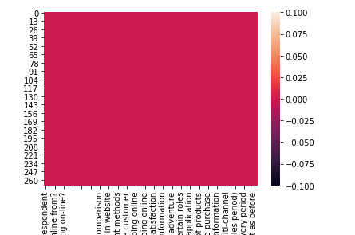

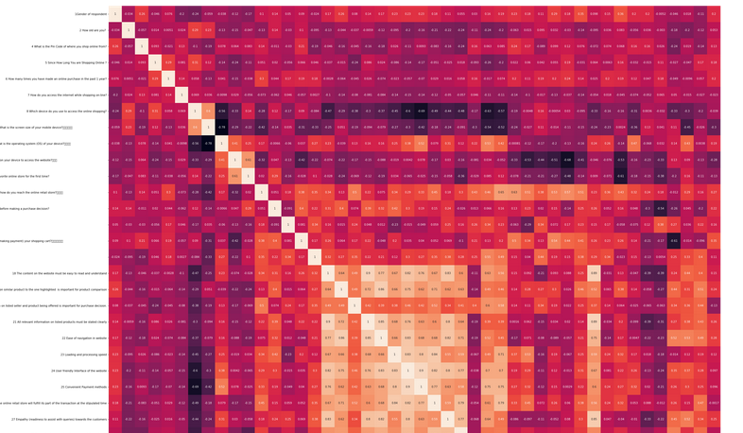
As you can see there are no null values and and then we will fing the correlation of the dataset, as we know correlation defines the realtion between the variables

s after that for checking the distribution of the data so i have used histplot

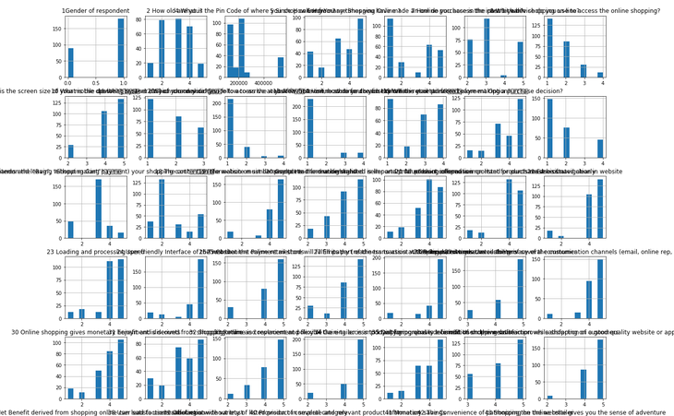

as we can data is a bit distrubuted and also lets continue with outlier
Outliers are most important concept of the machine learning project if we have
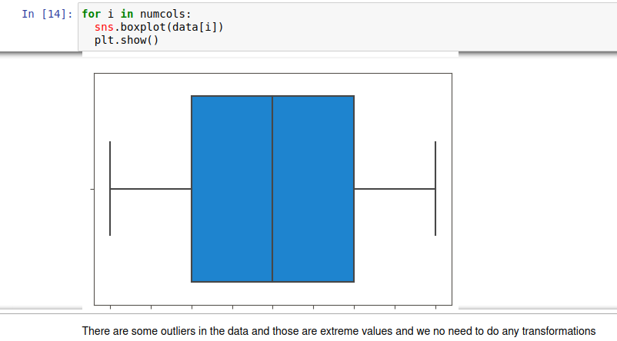
and next actually we have more columns and we can’t decide to wich we have to comppare them so we are using some automated EDA for doing analysis, i have used Sewwetviz, dtale and dataprep for automated EDA
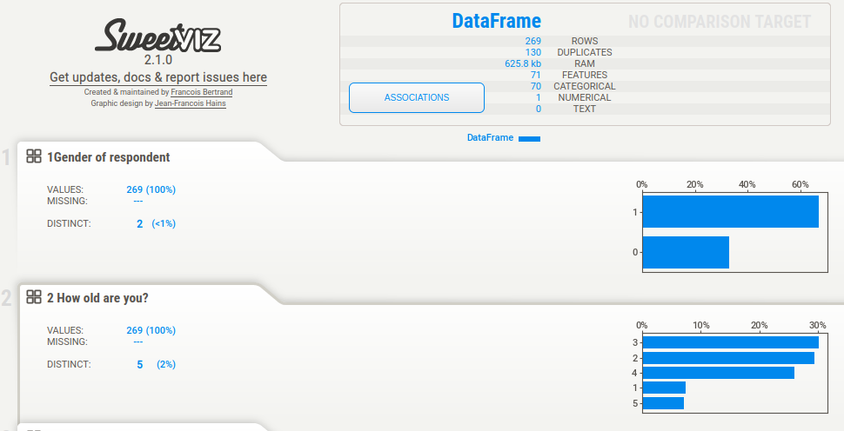

This is sweetviz an automated EDA which helps us to find all the relations between variables , and at last i have used other two automated EDA dtale and dataprep

CONCLUSION

- Key Findings and Conclusions of the Study
when we comare all the variabes of the data set we find
people find those e commerse sites which has short
loading time, great deals and and short loading time
products

- Learning Outcomes of the Study in respect of Data Science
From this project we can learn about many thing lik e how to handle the immbalanced dataset along with how to handle the larger dataset and how we are changing datatypes from one to another and we will know how to handle lagrer datasets by adjusting the parameters and through visualization how data is acting in which parameters
- Limitations of this work and Scope for Future Work
There is only one limitation as the data is very big we have to use many parameters for optimiszing the results good and that takes more time to provide solution, mainly the the process takes more time to solve for eg some plots took longer time to load .

